Faculty of Computing



**[CCN]**

**Lab No 9 (Create Network Topology using Commands)**

Router configuration modes: 1- User mode ( router > ).

1- Privilege mode ( router # ).

2- Global configuration ( router (config)#) .

enable disable

Global

Privilage conf t exit

User

Use packet tracer program for router configuration in the 3 previous modes. Choose router:

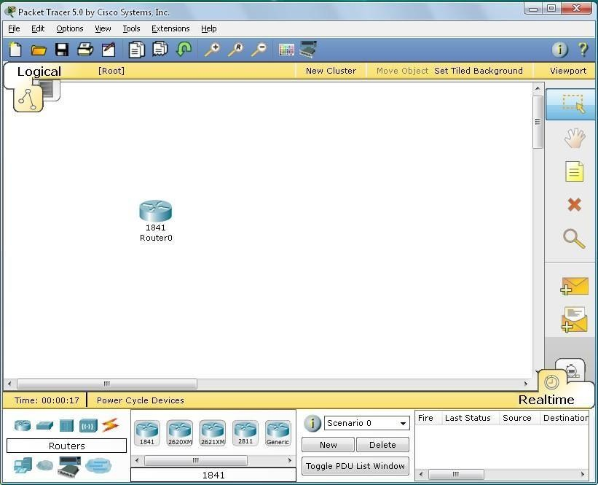

Double click on the router chosen:

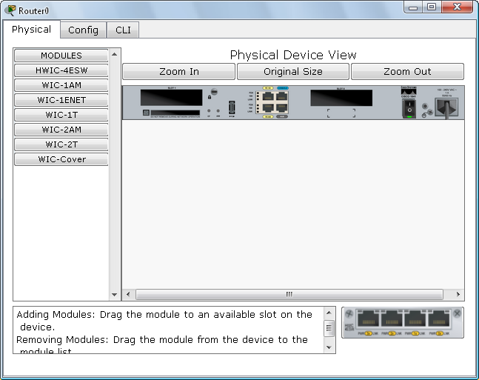

We enter CLI for router configuration:

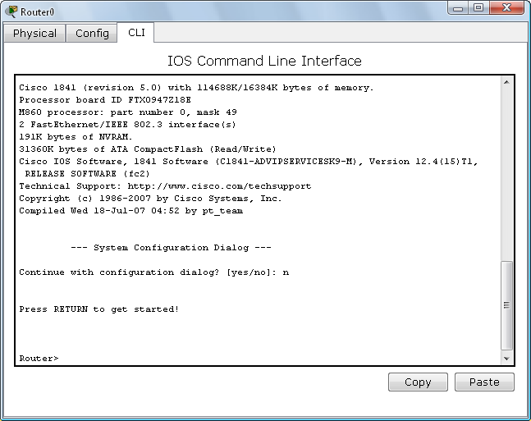

Now we are in the user mode:

To know the commands in user mode we use (?):

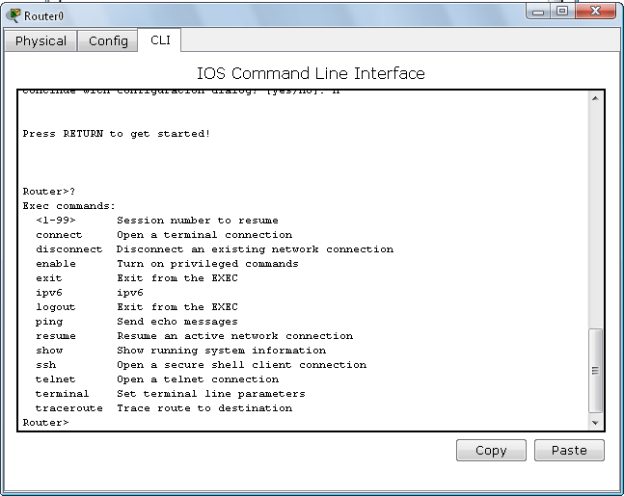

To enter the privilege mode, we use (enable):

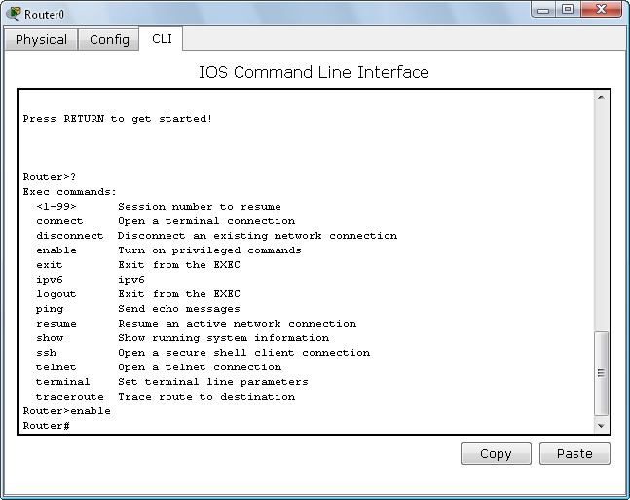

To see the commands in privilege mode we use (?):

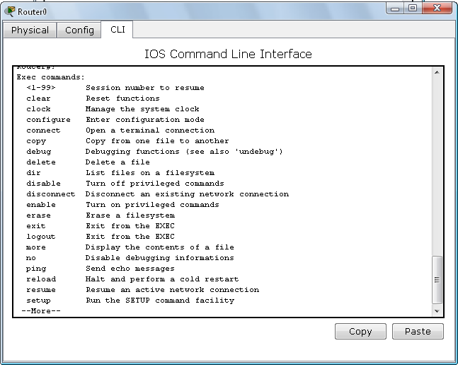

To manage the system clock, we use (clock):

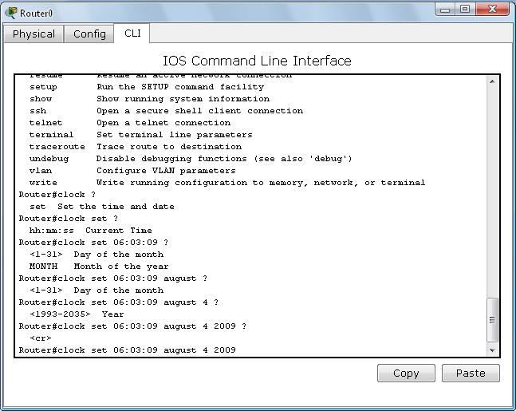

To see the time, we use (show clock):

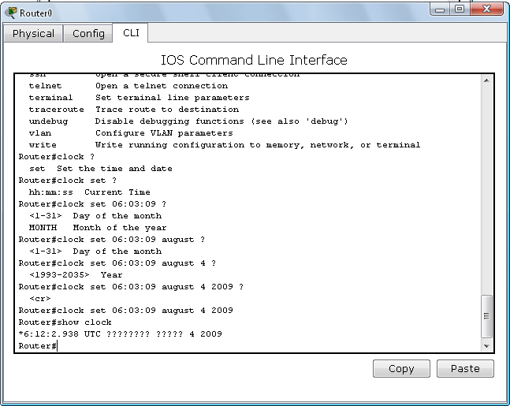

To see content of flash memory we use (show):

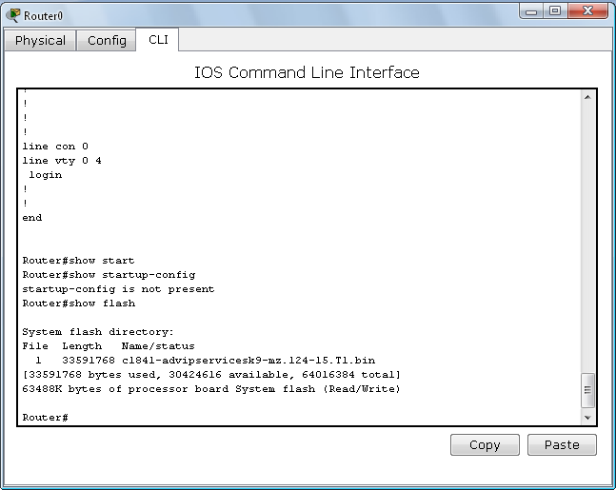

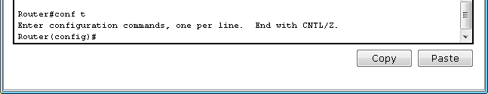To go to global configuration we use (conf t):

Passwords:

Lone console password to protect the user mode:

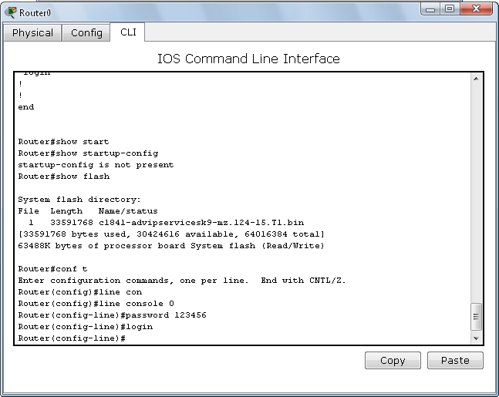

1. 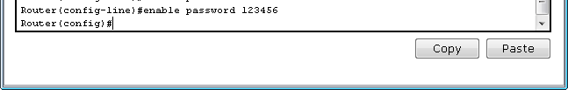Enable password to protect the privileged mode:
2. Secret password for more protection of privileged mode (more priority than enable pass and its encrypted pass.

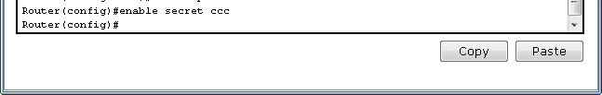

Now we try the passwords set:

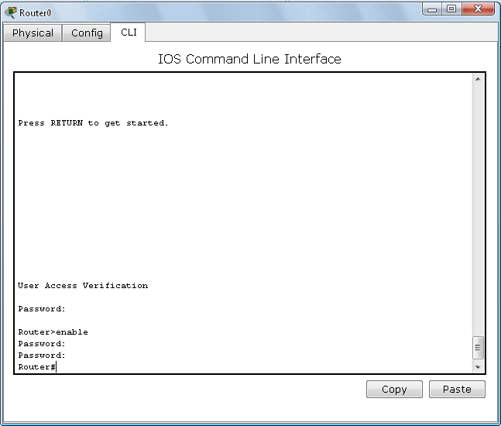

We notice that only secret pass is encrypted:

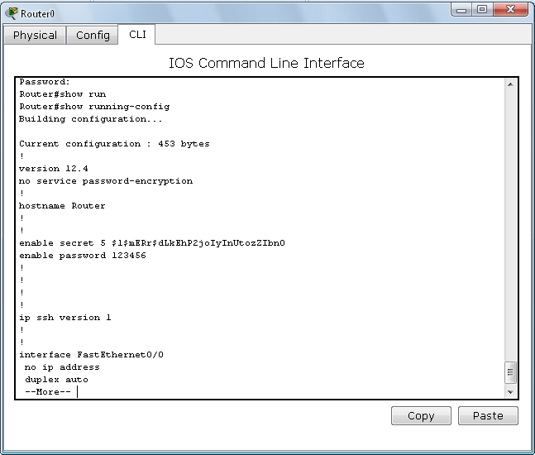

To restart we use the command (reload):

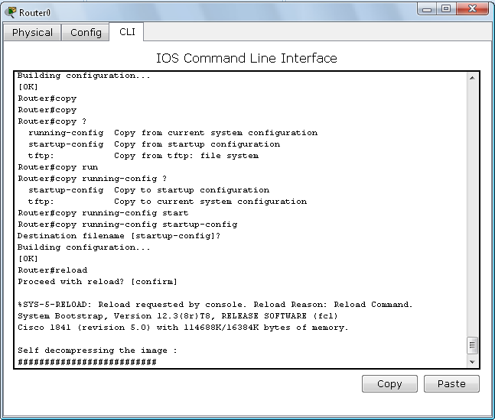

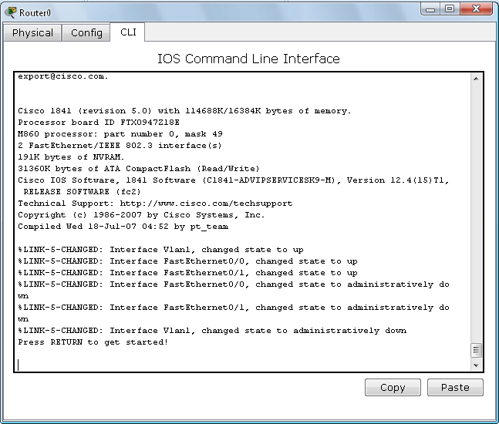

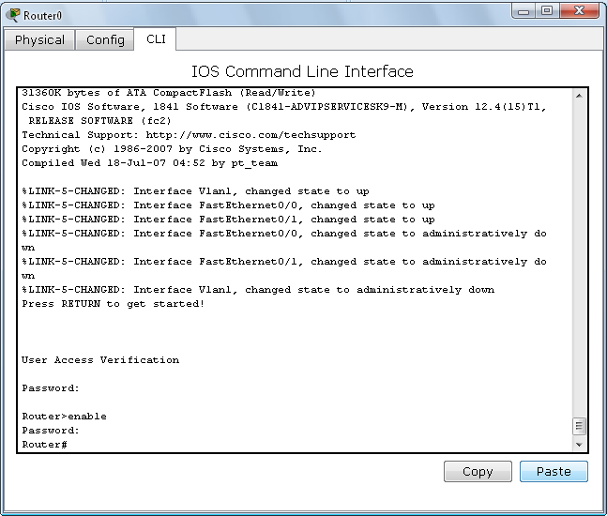

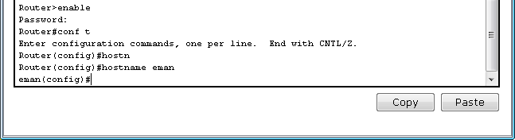To change the host name of router:

Using packet tracer in addressing: 1- We connect the figure. The cables used are:

Straight: between switch, pc and router, switch.

Cross: between switch, switch.

* Serial: between the two routers.

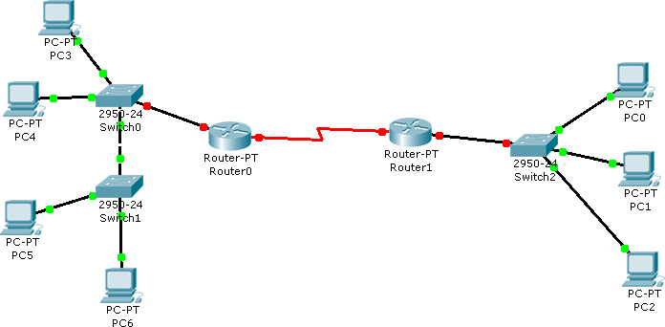

2- We put the IP address for each device as the following: We have in the figure 3 networks:

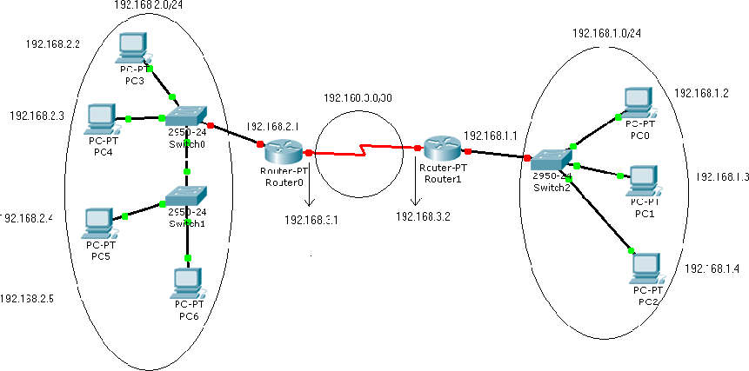

To distribute the Ip's on the router interfaces we do the following:

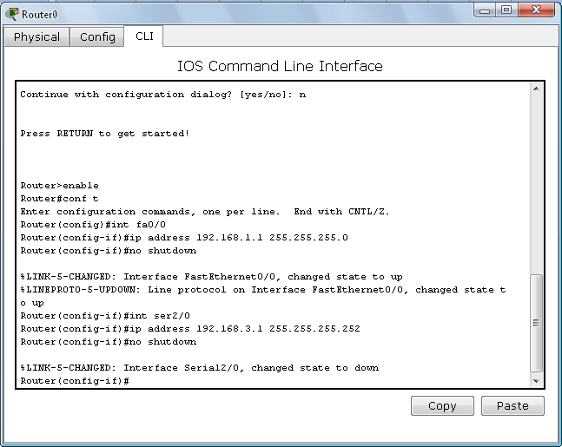

To make sure of the IP:

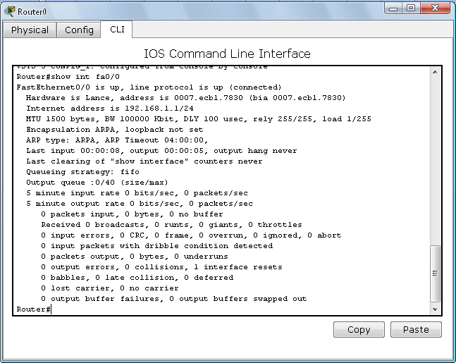

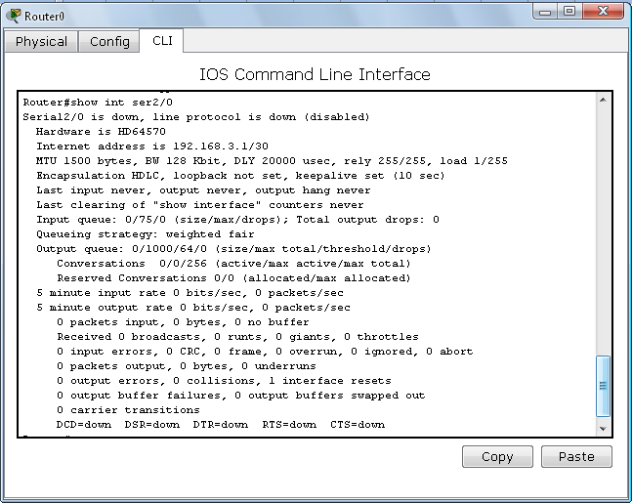

For the second router:

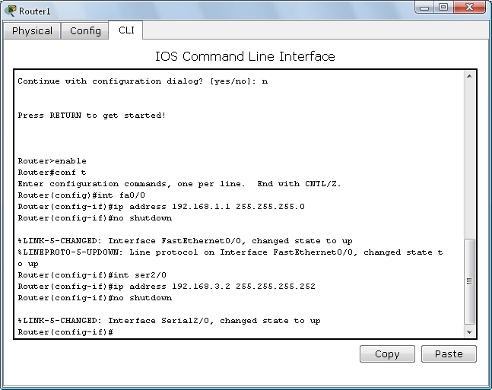

To make sure of IP's:

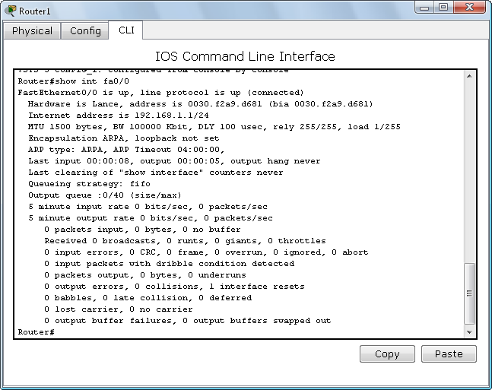

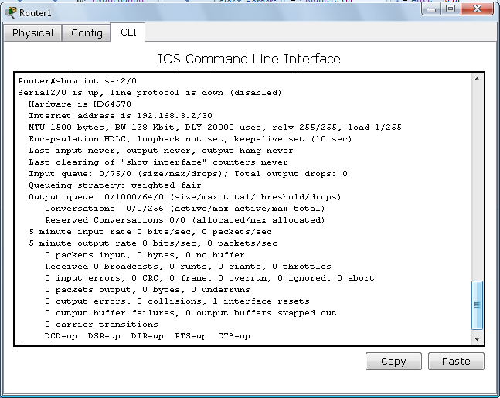

Now we notice that all points in the figure became green:

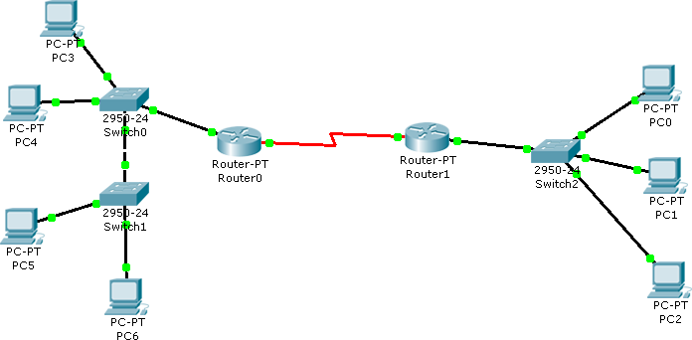

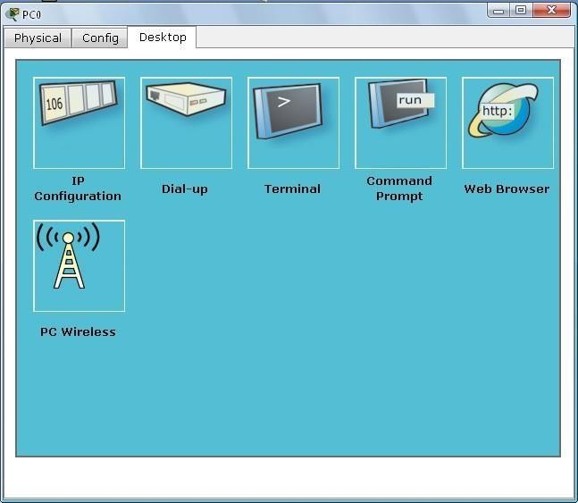How to ping on default gate way: For PC0:

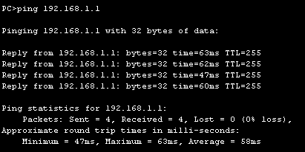We chose command prompt and ping on the default gateway: